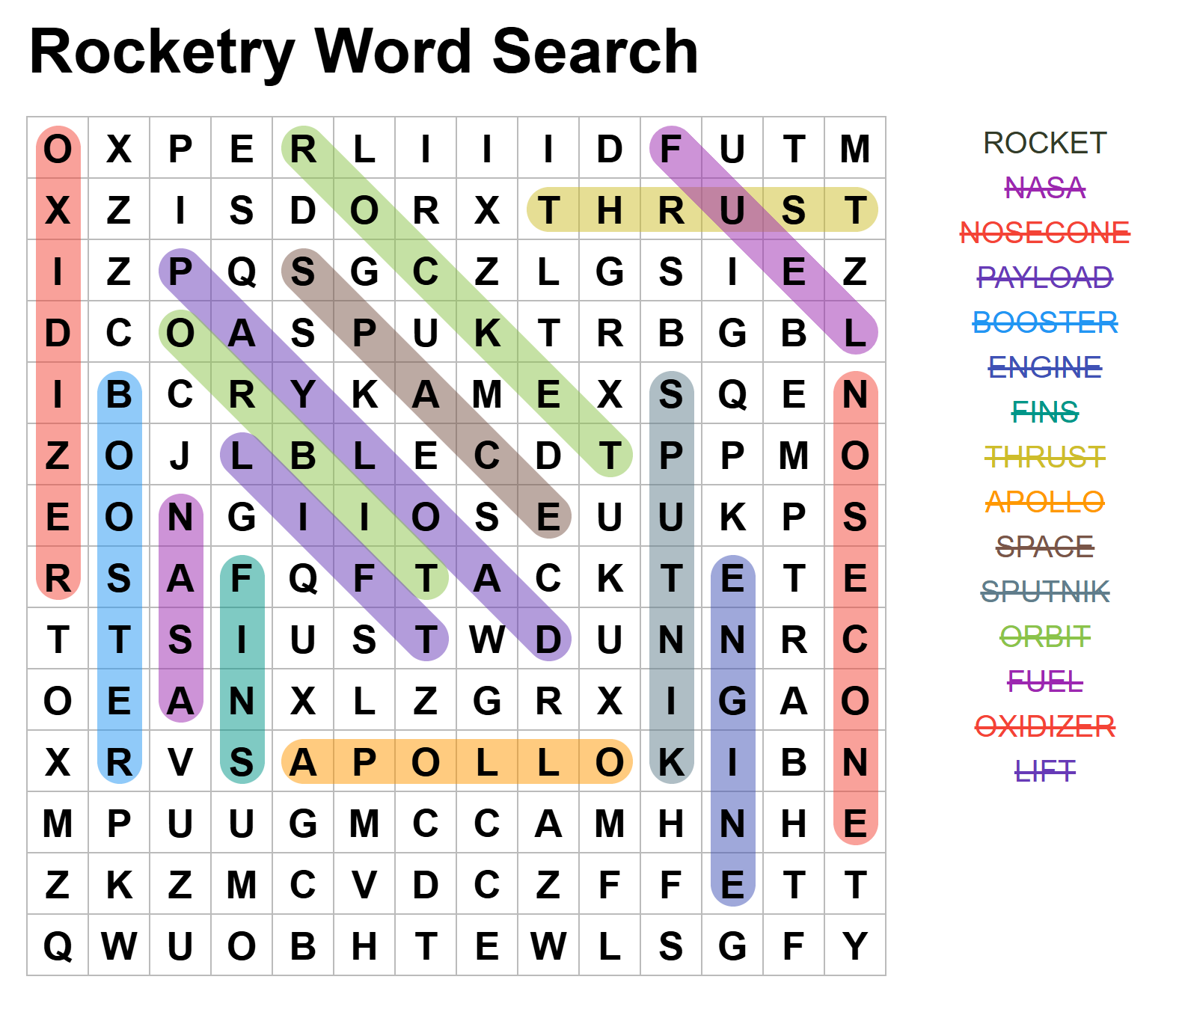

Unscramble the words:

Rocket

Engine

Combustion

Force

Aerodynamics

Thrust

Leading Edge

Propulsion

Stability

Apollo

Acceleration

Inertia

Crossword:

Across:

2. Apogee

5. Voyager

9. Aeronautics

10. Light Year

13. John Glenn

14. Vectoring

1. Vostok

3. Space Shuttle

4. Surface Area

6. Reaction

7. Cosmonaut

8. Hubble

16. Shields

17. Saturn V

11. Attitude

12. Pressure

15. Fins